**Router Configuration:**

Configuring a wireless router involves setting up the device to connect to your Internet service provider (ISP), securing your wireless network, and configuring other settings based on your needs. Here's a step-by-step guide to help you configure your wireless router:

**STEP 1**: **Unbox and Connect the Router.** and take out the power adapter, Ethernet cable, and the router itself. Connect the power adapter to the router and plug it into a power outlet.

Use an Ethernet cable to connect the router’s WAN (Internet) port to the modem’s LAN (Ethernet) port.

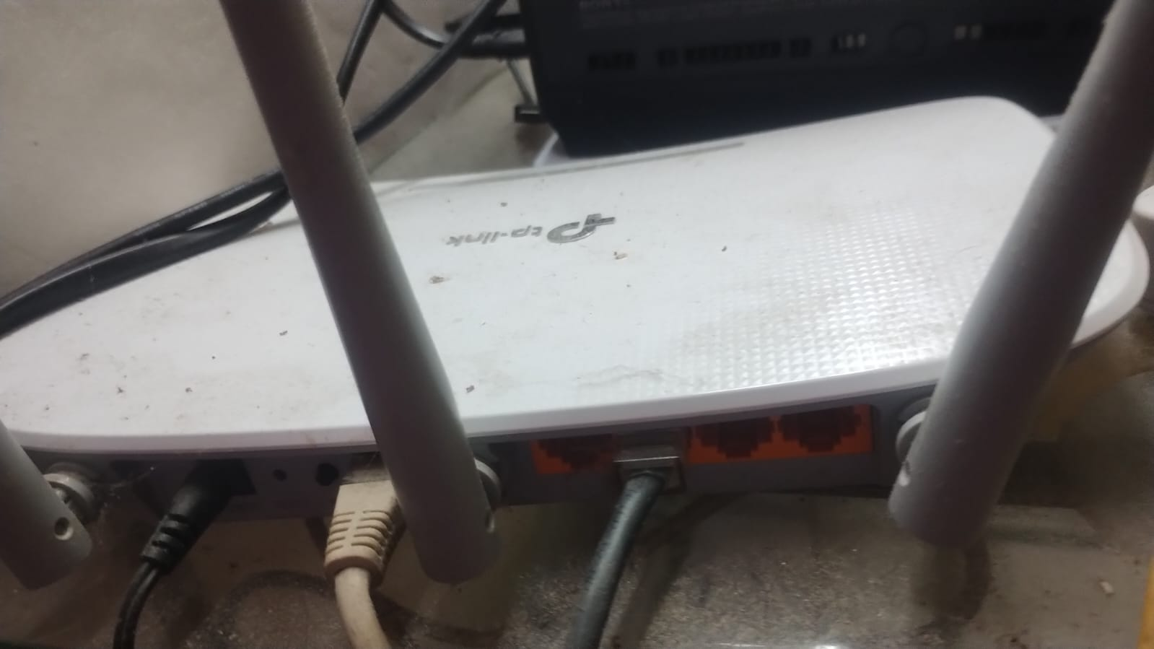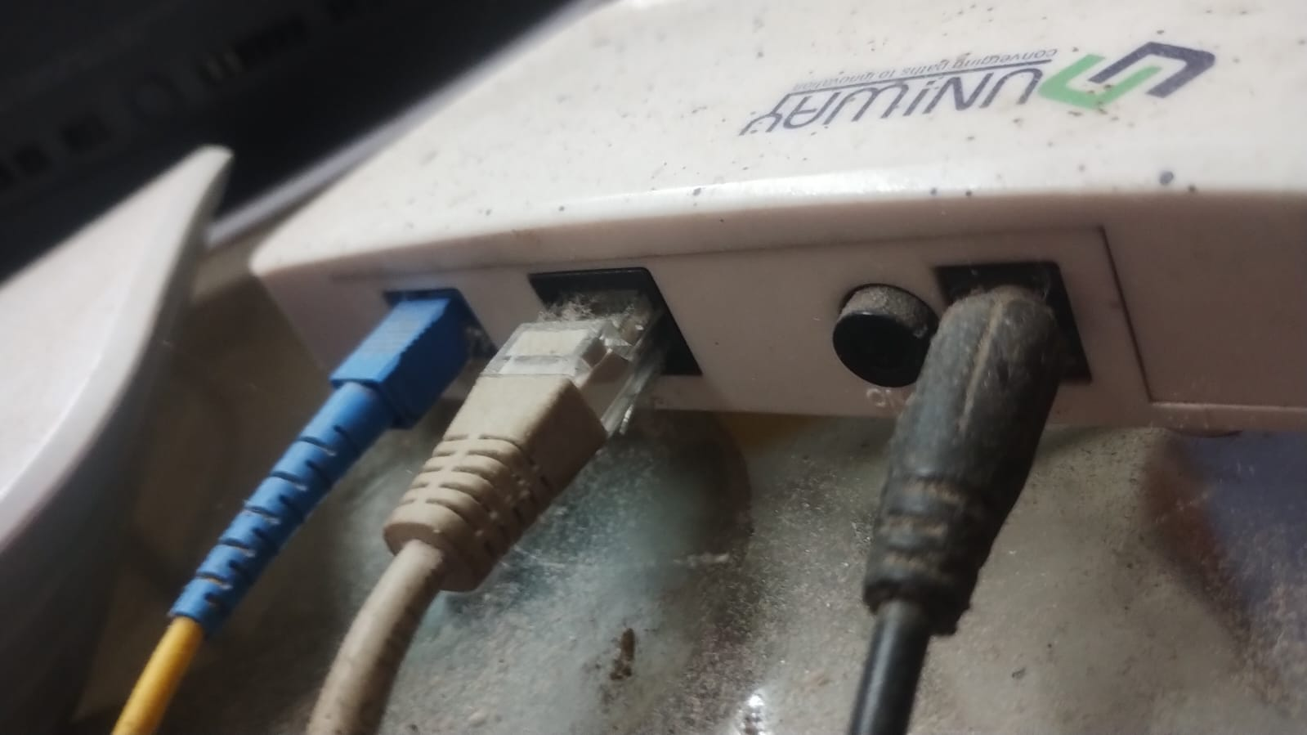

Connect your computer to the MODEM via Wi-Fi or using another Ethernet cable connected to one of the router’s LAN ports.

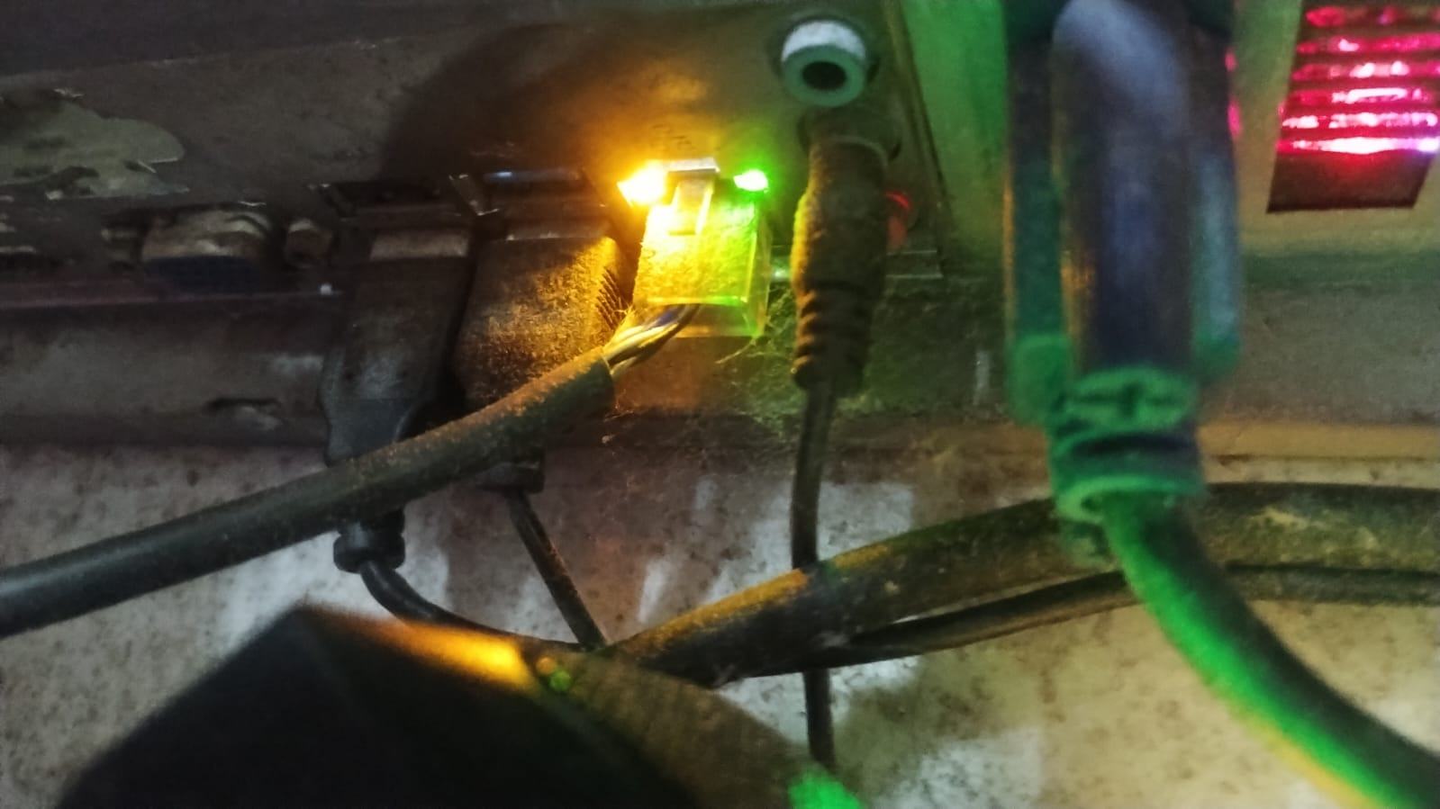

**STEP 2**: Open a web browser and enter the router’s default IP address in the address bar. Common IP addresses include 192.168.0.1, 192.168.1.1, or 192.168.10.1

Here ‘Default Gateway’ is my home Router’s IP address can be check by **ipconfig** command.

Default Getway of my router is **192.168.0.1**

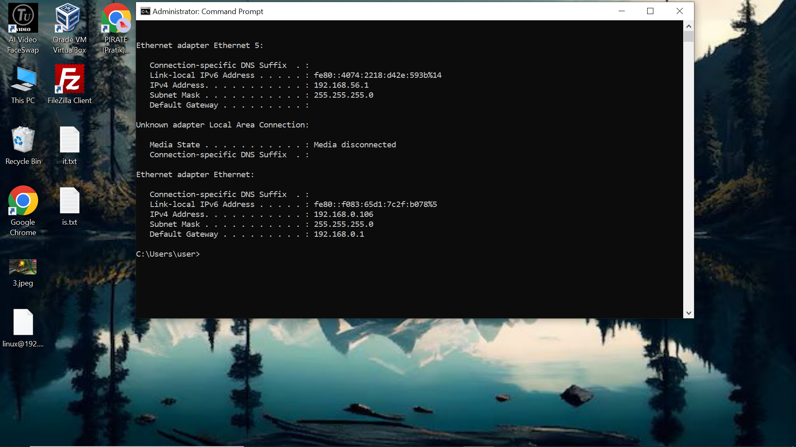

**Step 3:** Log in using the default username and password, which can usually be found on the router itself or in the user manual. Common defaults are **admin** for both username and password.

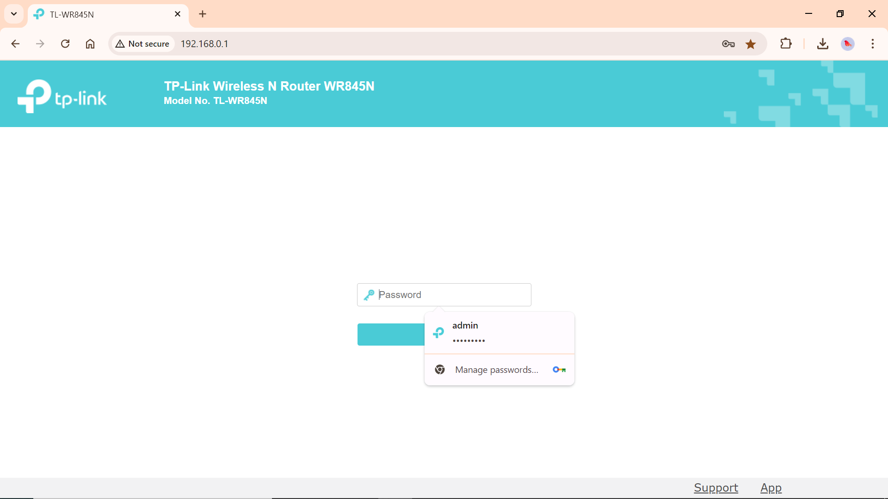

**Step 4:** **Set Up SSID (Network Name)**: Go to the wireless settings section and change the SSID to a name of your choice.

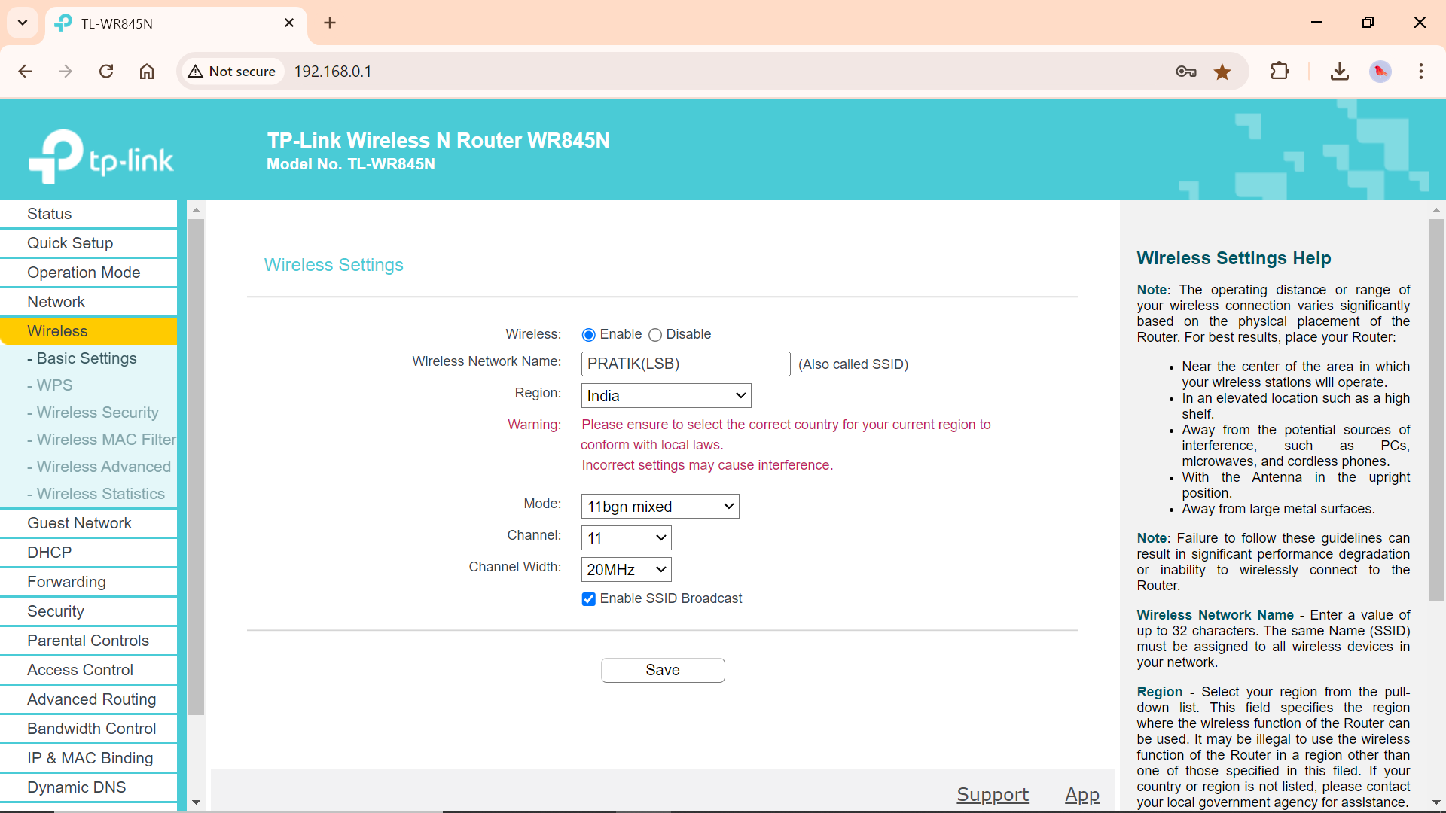

**Step 5:** **Secure Your Network**:

* **Choose Encryption**: Use WPA3 or WPA2 if available for better security.
* **Set a Strong Password**: Choose a strong, unique password for your wireless network.

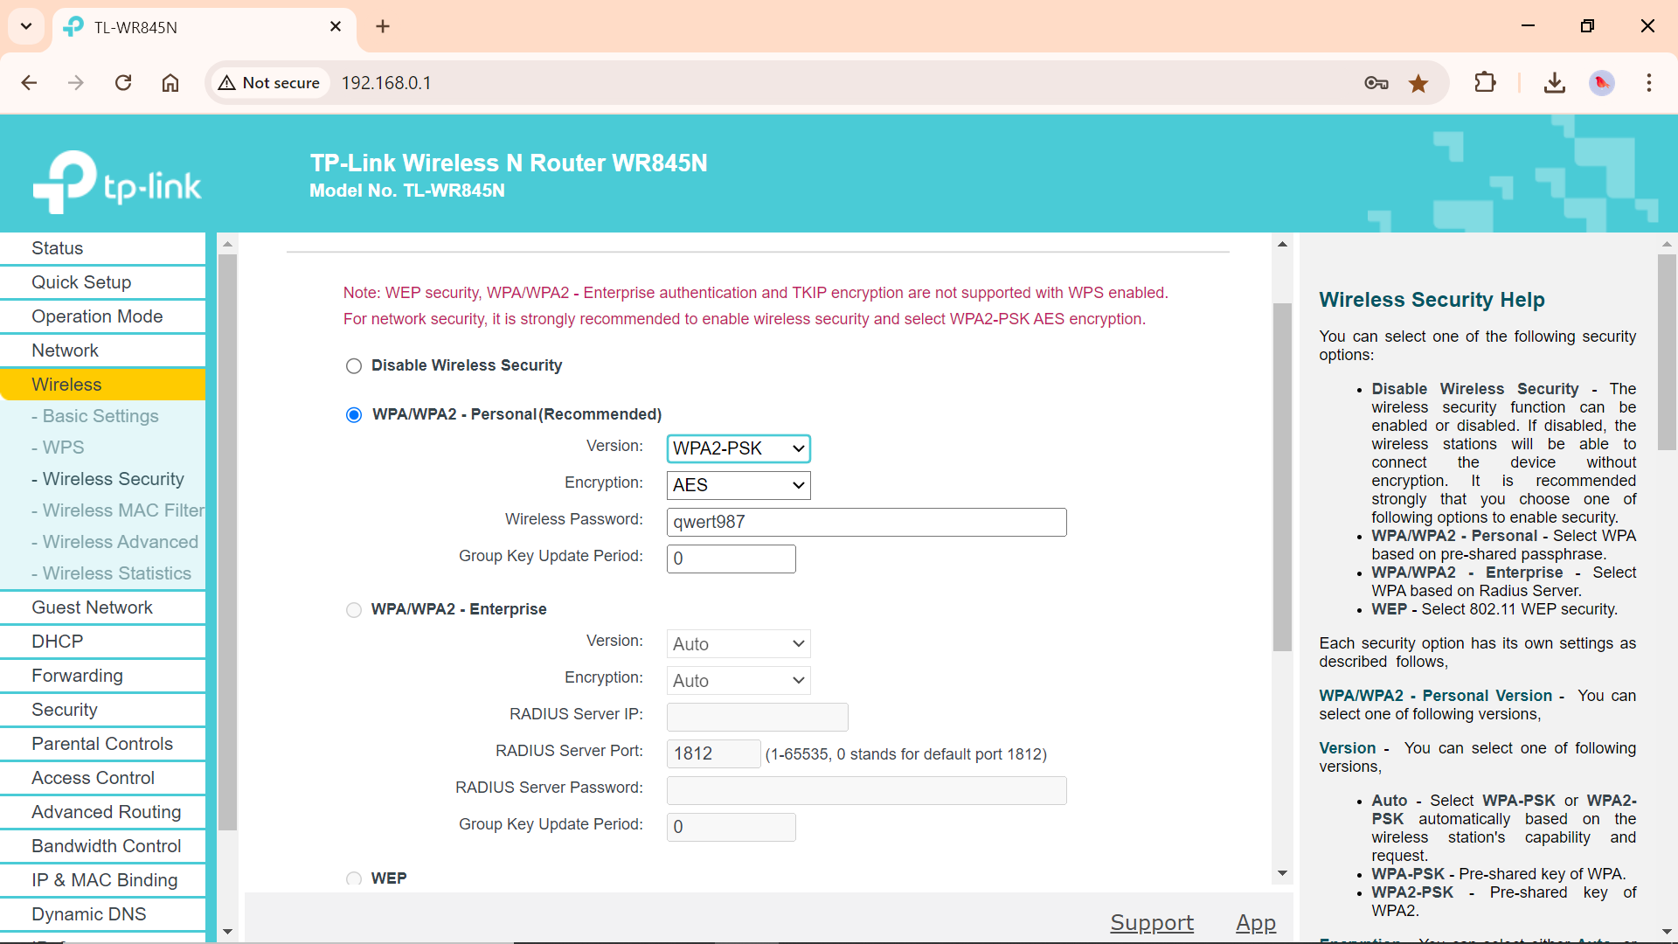

**Step 6:** **configure DHCP** (Dynamic Host Configuration Protocol). DHCP automatically assign IP addresses to devices on the network

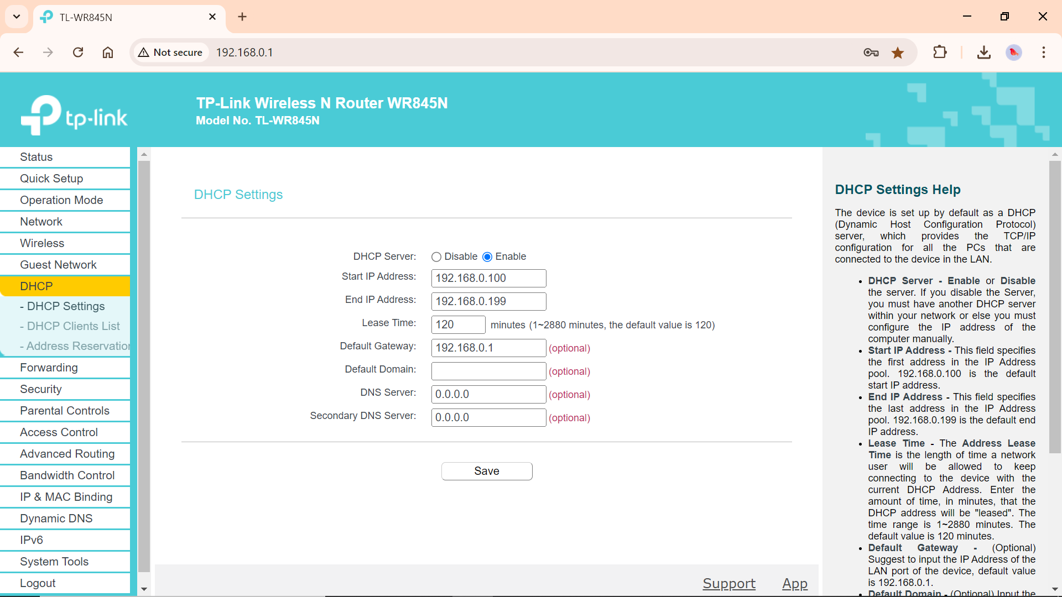

**Step 7:** **Enable Firewall**

A firewall in a router is a security feature designed to protect your network and connected devices from unauthorized access and potential threats from the internet. It acts as a barrier between a trusted internal network (your home or office network) and an untrusted external network (the internet).

Stateful Packet Inspection (SPI) helps to prevent cyber attacks by tracking more state per session.

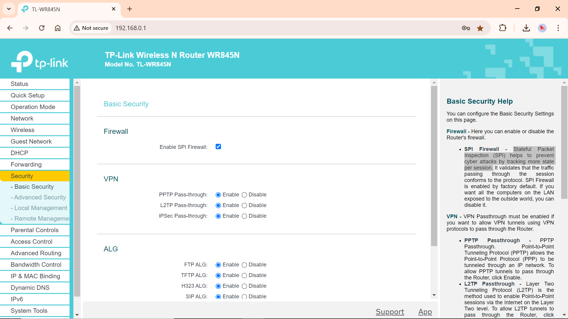

**Step 8:** **Update Firmware**:

* Check for firmware updates under System Tools > Firmware Upgrade or similar. Follow the prompts to download and install the latest firmware from TP-Link’s website.

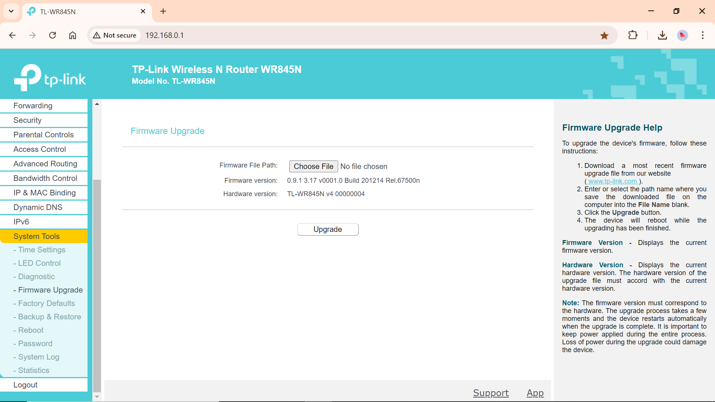

**Step 9: DHCP Clients List:** Here are the list of devices are added to my Router’s network. I can check their IP address and MAC address along with their Device names and Lease time.

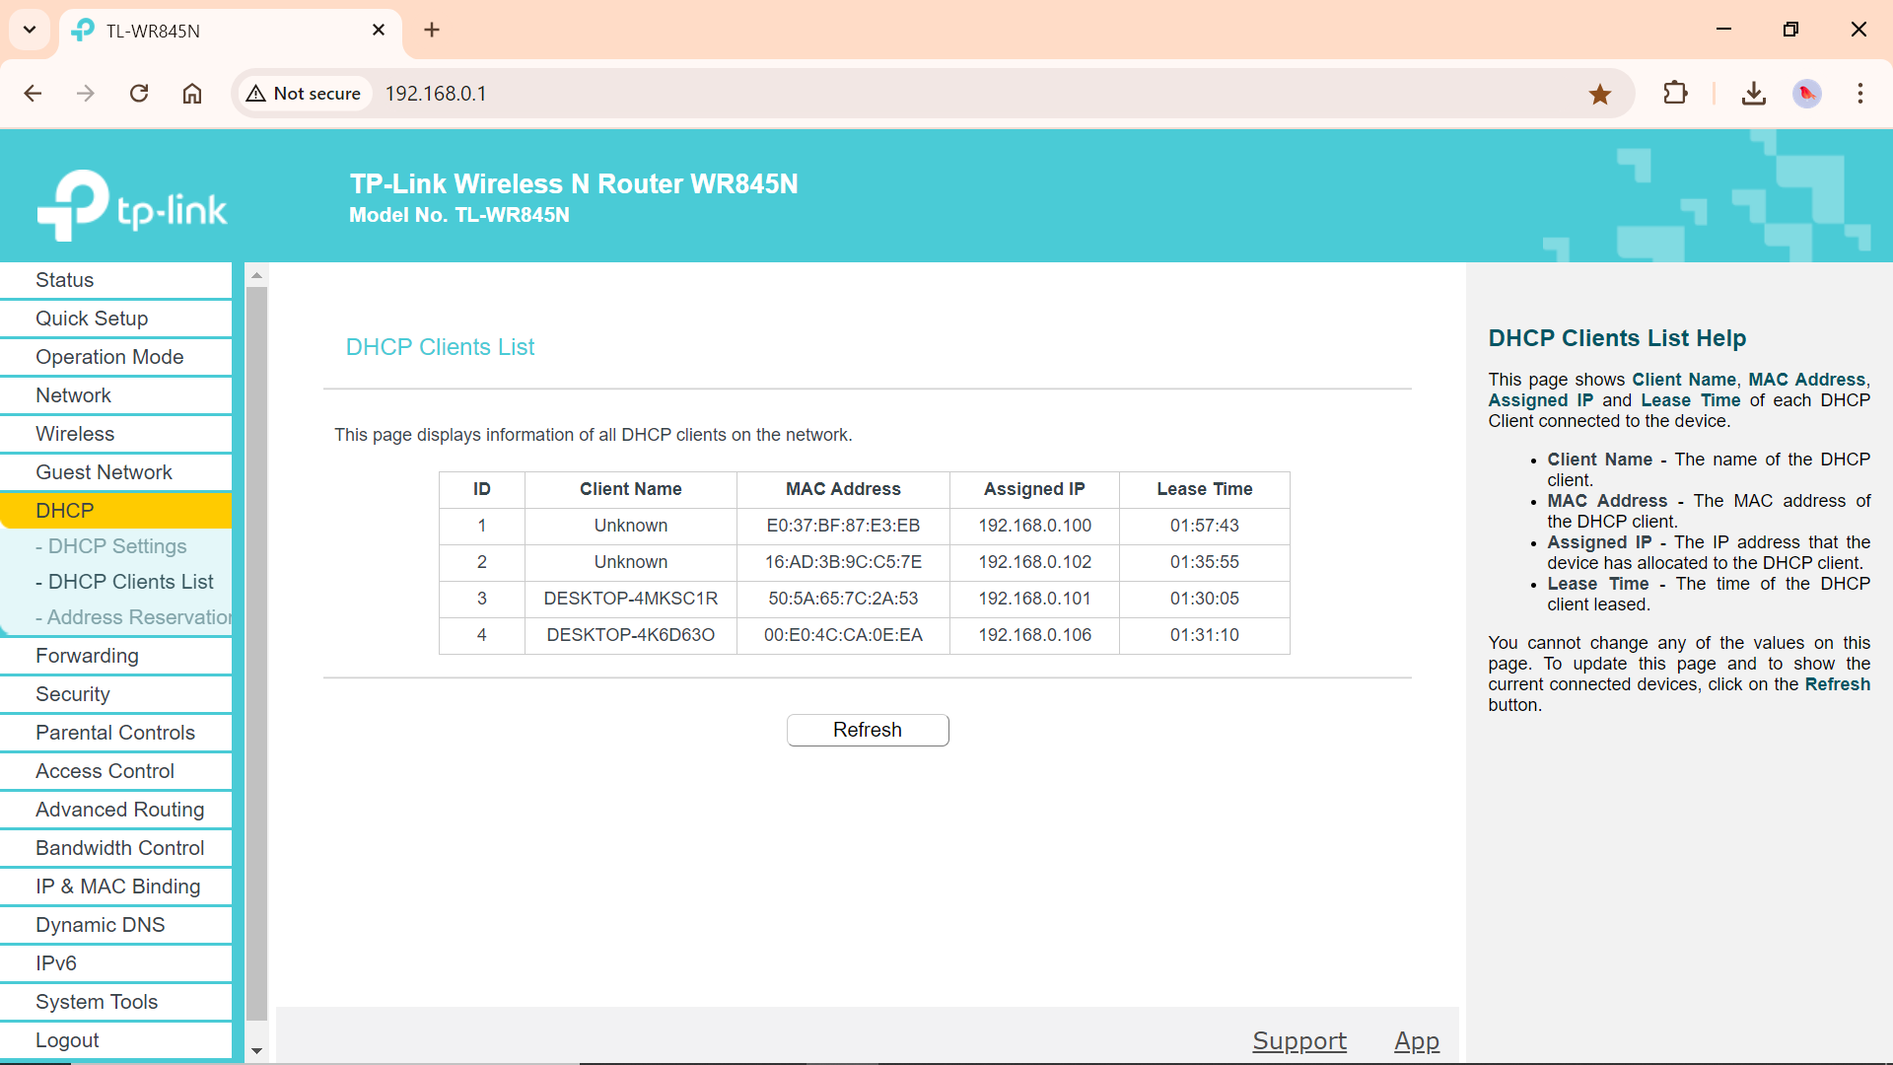

**Step 10:** we can manage ‘Parental controls’ that provide a restricted access to certain websites. add the MAC addresses of the PCs where I want to have ‘parental control’.

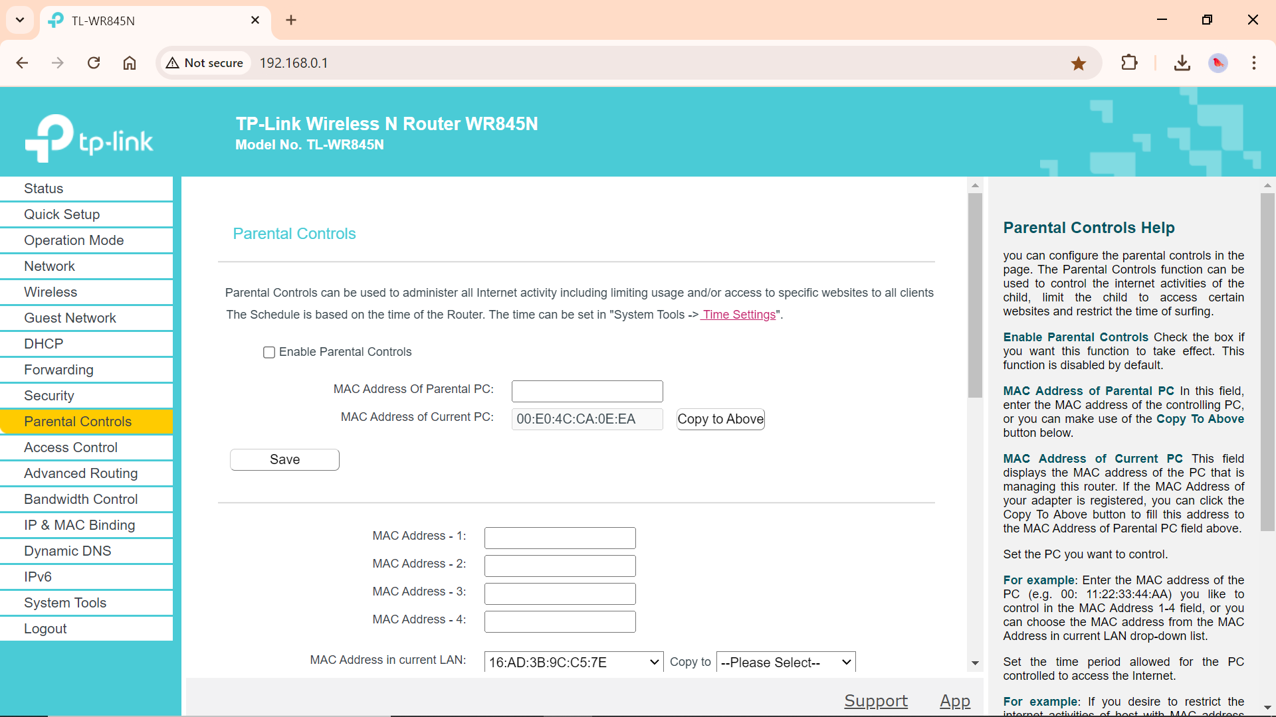

Now set the schedule time and add URL of the website which I want to restrict access.

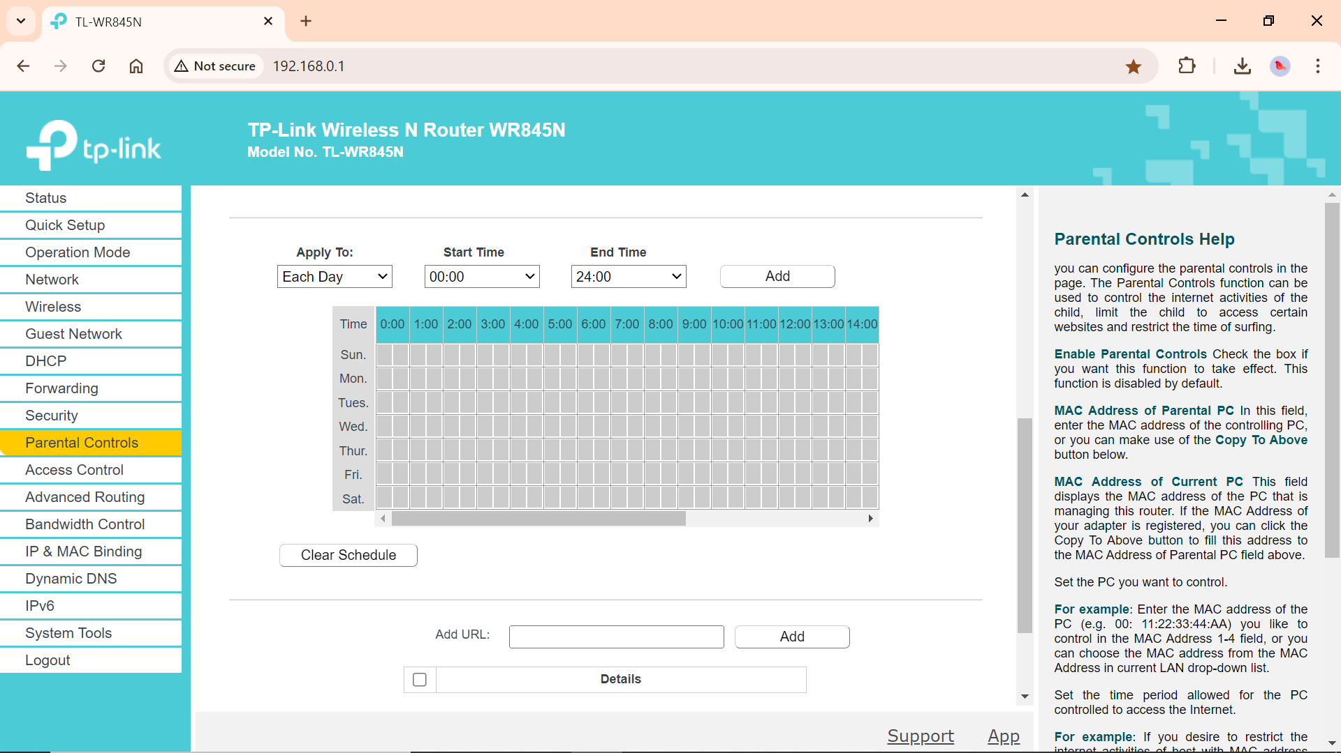

**Step 11: Save and Apply Changes**:

* Make sure to save your settings and apply changes. Some routers might require a reboot for changes to take effect.

